**Name: Shivani Tyagi**

**Roll Number: R171218097**

**SAP ID: 500067253**

**Experiment no-14**

**Deploy static HTML Website as container**

**Solution:**

**Step 1 – Creating a Dockerfile**

There is no customized docker image created till now:

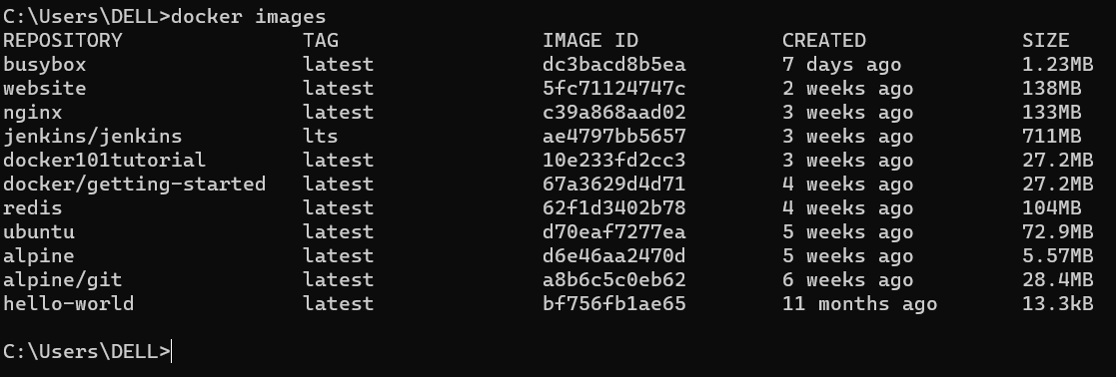

We create a “Dockerfile” with the following content:

FROM nginx:latest

COPY . /usr/share/nginx/html

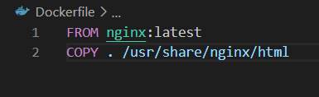

The files that are going to be copied are static website files

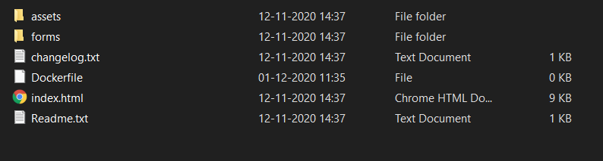

**Step 2 – Build Docker Image**

To create a docker image, run the following command:

docker build -t my-nginx-server:v1 .

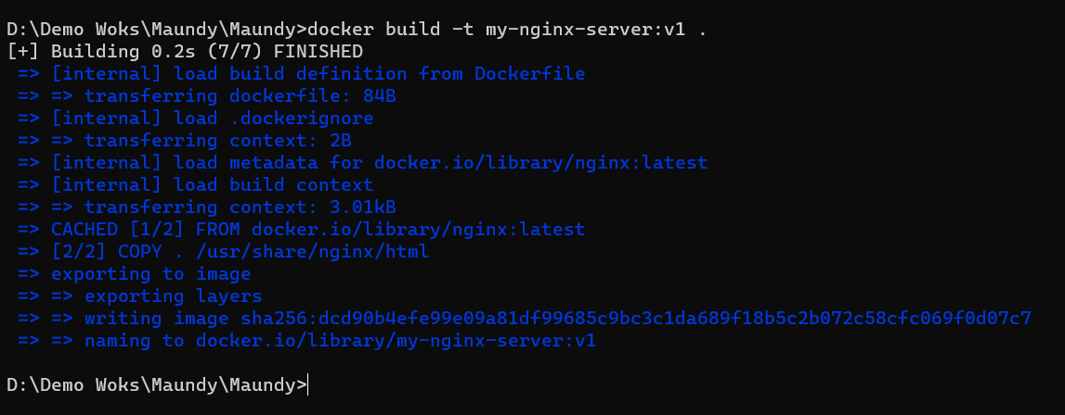

To check if the custom image was created, use the following command:

docker images

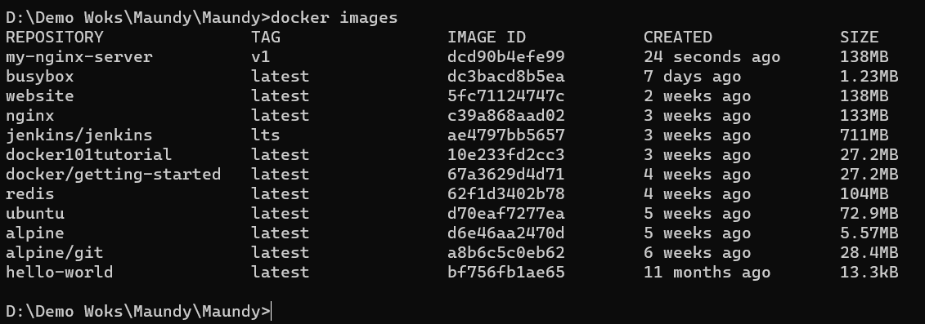

**Step 3 – Running Docker Image**

To run the docker image use the following command:

docker run -d -p 80:80 my-nginx-server:v1

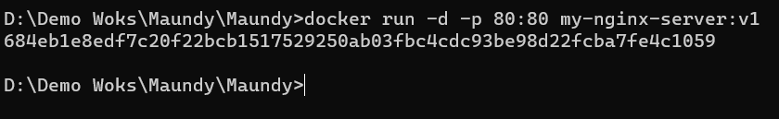

To view your hosted website, visit:

https://localhost:80

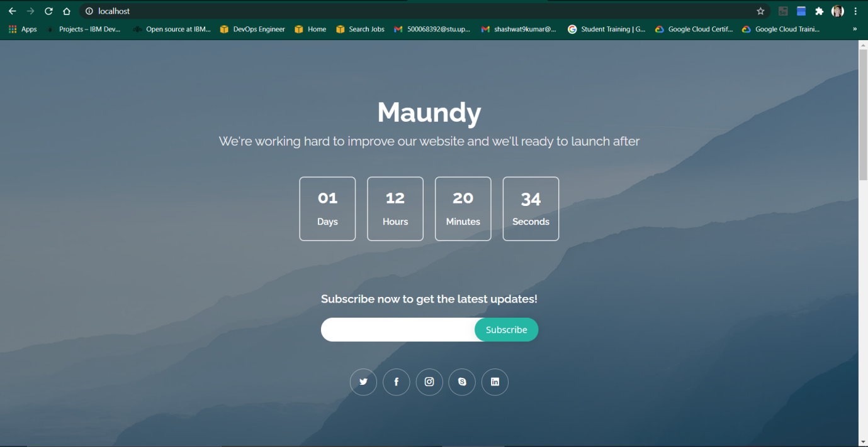

**Step 4 – Terminating the image**

Run the following command to terminate the running image:

docker rm -f 684eb1e8edf7 ## use your own image number

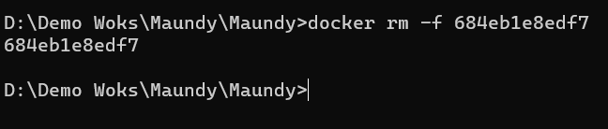

Check that the image stopped by visiting:

https://localhost:80

